Assignment: Styling a Portolio Card with CSS
Import HTML Code
- Copy the provided HTML code (index.html) into your editor (VS Code or any other).
- Create a new CSS file (style.css) and link it to the HTML using: Perform CSS Tasks Step by Step
- Apply the CSS rules as described in the task list (selectors, colors, text, units, backgrounds, flexbox, etc.).
- Do one task at a me.
Documenta on (Screenshots + Report)
- A er comple ng each step, take a screenshot of your webpage.
- Paste all screenshots in a Word or PDF report with a cap on (e.g., “Step 3: Styled the naviga on bar using inline-block”).
Repor ng Doubts
- If you face difficulty or get an error, do not skip the step completely.
- Write the ques on number, explain what went wrong, and write your doubt clearly in the report. Example:
 Task 5: I tried to use display: flex; but my projects are not aligned. Why is it not working?
- Modifying HTML (if required)
- You are allowed to make small changes in the HTML code (e.g., adding a new class, changing text, inser ng more elements) if needed to complete your styling tasks.
- If you modify the HTML, highlight the change in your report.
- Final Submission
- Your submission should include:
  - The HTML & CSS files
  - The Report (Word/PDF) with screenshots + doubts

Html code
<!DOCTYPE html>
<html lang="en">
<head>
<meta charset="UTF-8">
< tle>Mini Project - Por olio Card</ tle>
<link rel="stylesheet" href="style.css">
</head>
<body>

<header id="main-header">
<h1 class="site- tle">My Por olio</h1>
<nav>
<ul>
<li><a href="#">Home</a></li>
<li><a href="#">Projects</a></li>
<li><a href="#">Contact</a></li>
</ul>
</nav>
</header>

<sec on class="profile-card">
<img src="h ps://via.placeholder.com/150" alt="Profile Picture" class="profile-img">
<h2 class="name">John Doe</h2>
<p class="bio">Web Developer | Learner | Tech Enthusiast</p>
<bu on class="btn">Hire Me</bu on>
</sec on>

<sec on class="projects">
<h2 class="sec on- tle">Projects</h2>
<div class="project-list">
<div class="project">Amazon Clone</div>
<div class="project">Pizza Stop Website</div>
<div class="project">Farmhouse Booking</div>
</div>
</sec on>

<footer id="footer">
<p>&copy; 2025 My Por olio</p>
</footer>

</body>
</html>

Student Tasks – Apply CSS (in style.css)
- Selectors & Colors
  - Use the universal selector * to reset margin and padding to 0.
  - Use an element selector to make all <p> tags gray.
  - Use a class selector .site- tle → change text to blue.
  - Use an ID selector #footer → background black, text white.
  - Style .btn with background green, text white, rounded corners.
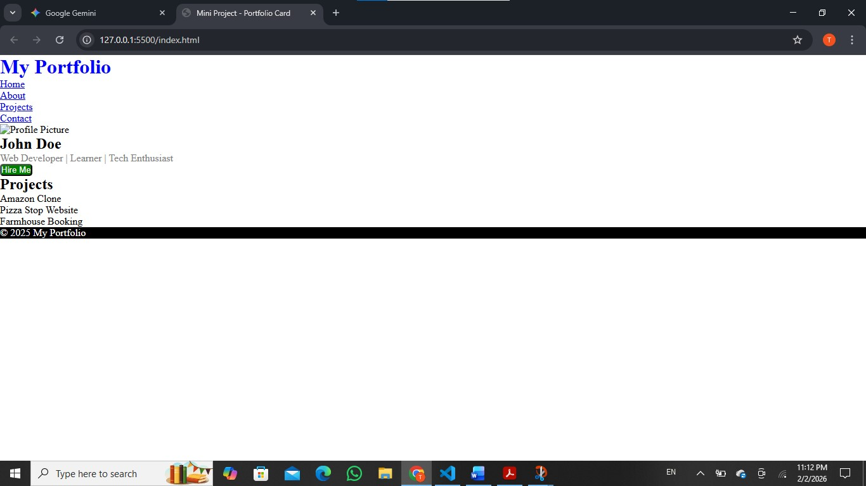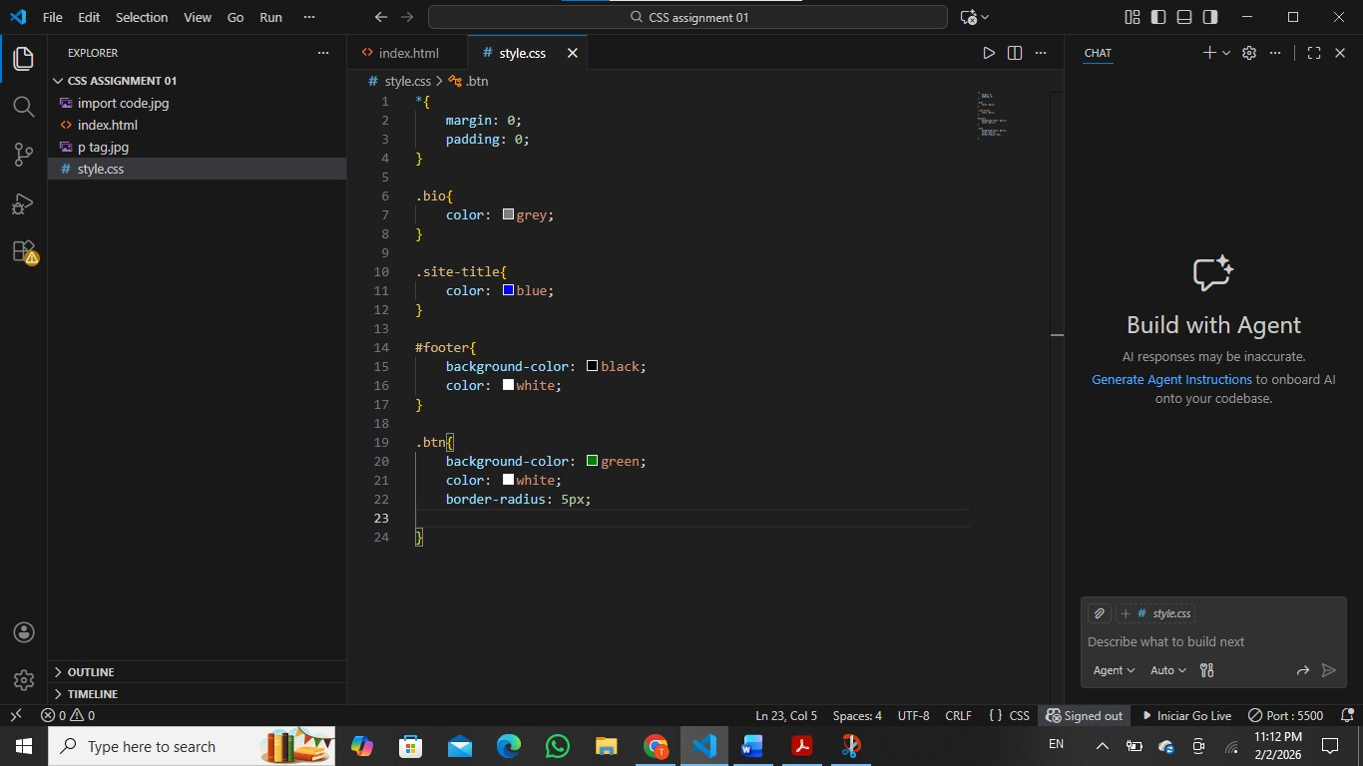

- Text Proper es
  - Center-align the site tle (.site- tle).
  - Make .name bold, uppercase, and font-size: 24px.
  - Use text-decora on: none; to remove underline from <a>.
  - Use text-transform: capitalize; for .bio.
  - Change font-family for body: Arial, sans-serif.
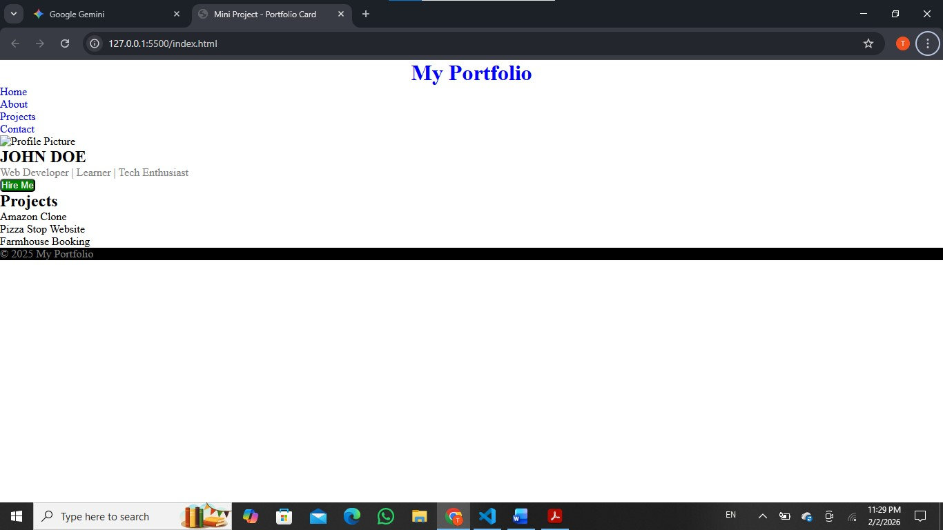

- Units & Sizing
  - Give .profile-card a fixed width of 300px and center it using margin: auto.
  - Set .profile-img width to 100% of the card.
  - Use rem units for heading sizes and em units for paragraph spacing.
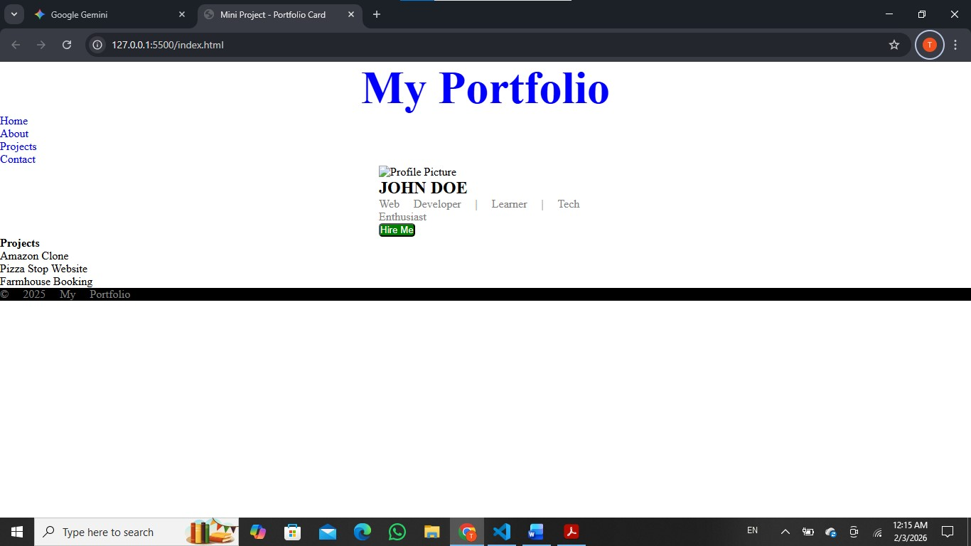

- Box Model
  - Add padding: 20px to .profile-card.
  - Add a border 2px solid #ddd around .profile-card.
  - Add margin: 20px between project boxes (.project).
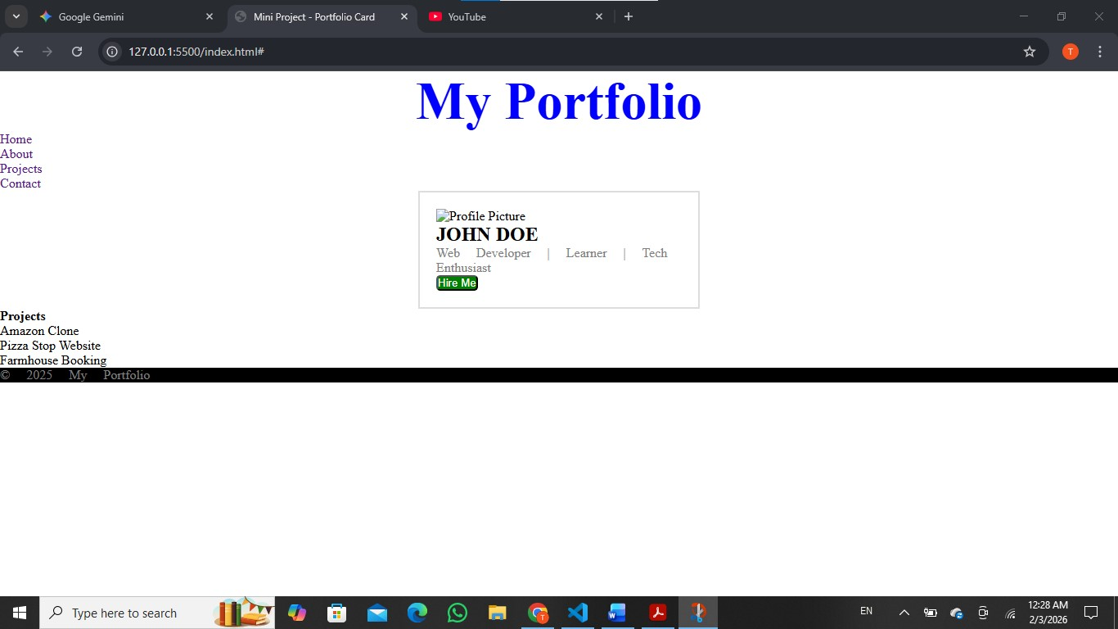

- Display Property
  - Change the nav menu (nav ul li) from ver cal list to horizontal using display: inline-block;.
  - Make .btn an inline-block so width & height can be set.
  - Hide the .bio temporarily with display: none; and then show it back.

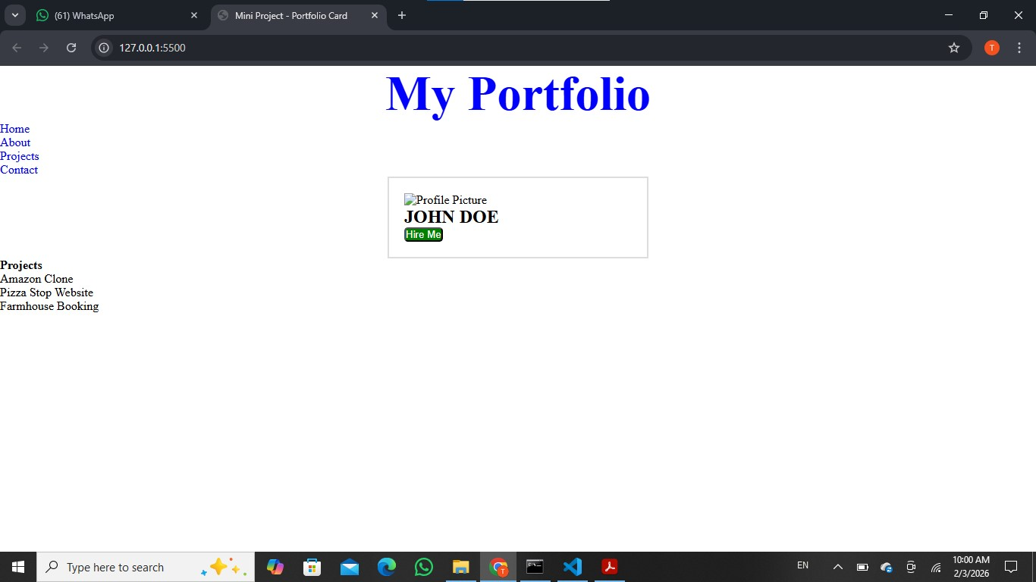

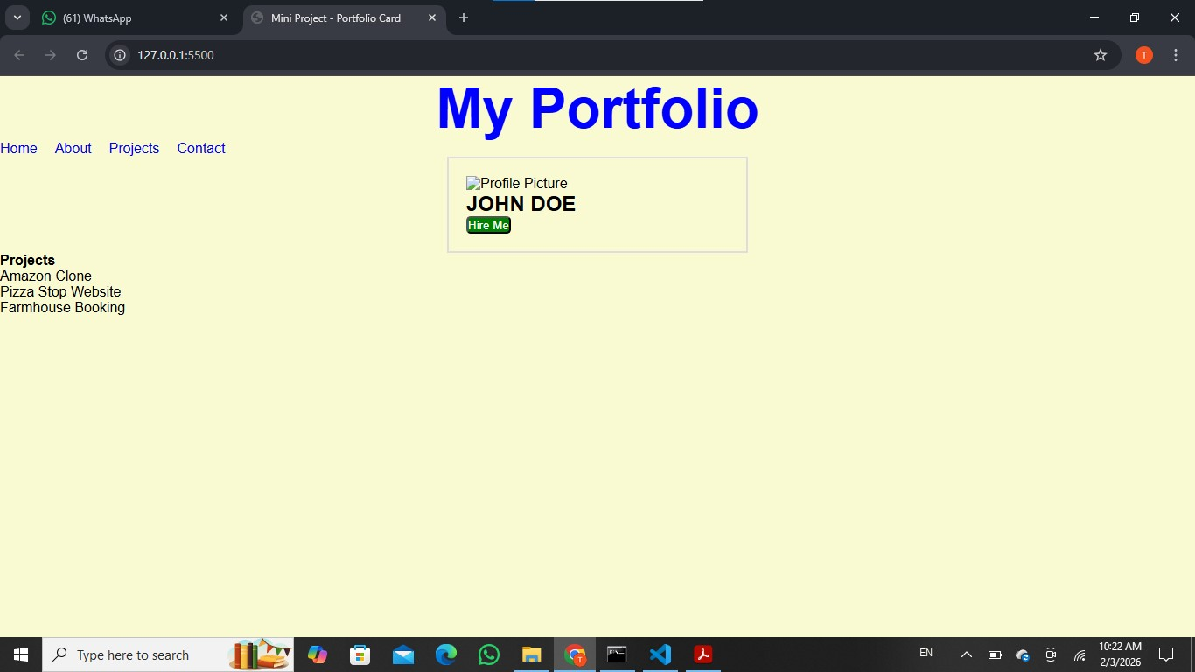
*ul property^

- Backgrounds
  - Add a background color to body.
  - Add a gradient background for .profile-card.
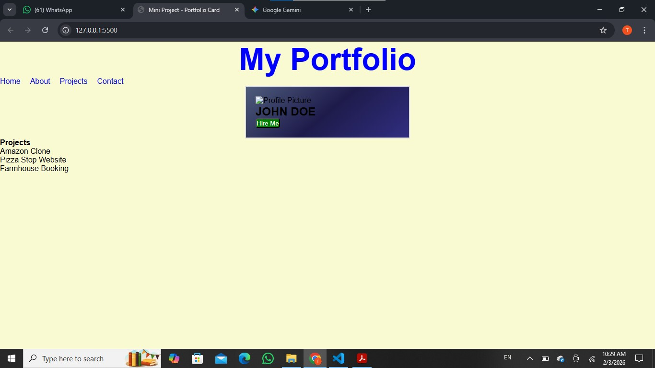

- Flexbox
  - In .project-list, use display: flex;.
  - Use gap: 15px; to add spacing between projects.
  - Use jus fy-content: space-around; to spread projects evenly.
  - Use align-items: center; if you add height to .project-list.
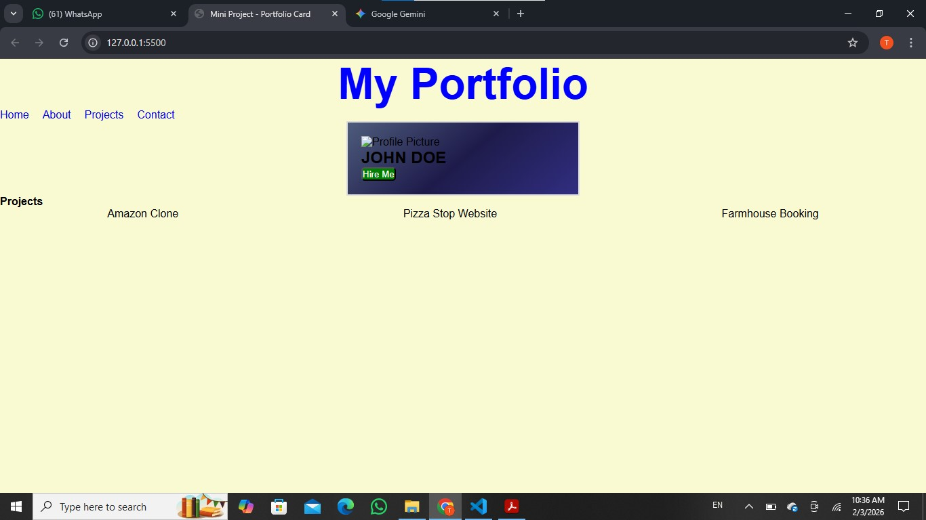

- Bonus Challenges
  - Add hover effect on .btn: background darkens.
  - Add hover effect on nav <a>: underline on hover.
  - Make .profile-img circular using border-radius: 50%;.
  - Use z-index to place the navbar above everything.
  - Make the navbar fixed (posi on: fixed; top: 0; width: 100%;).
